1. **Step 01**:   
   Create Spring Boot Microservice Project with dependency “Config Server”.  
   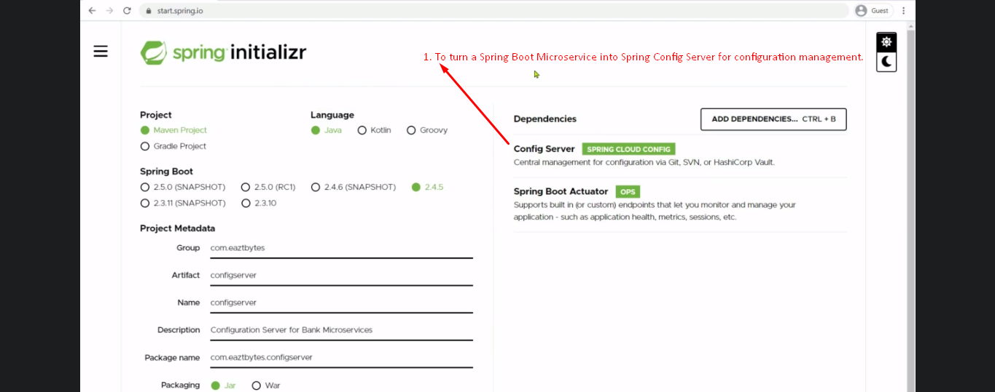  
   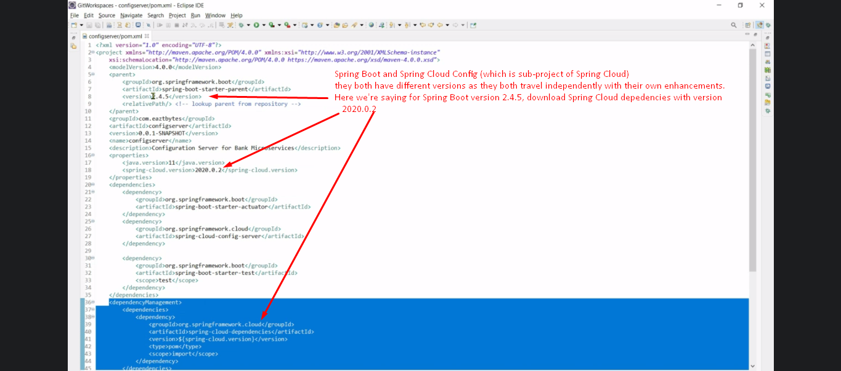
2. Step 02:  
   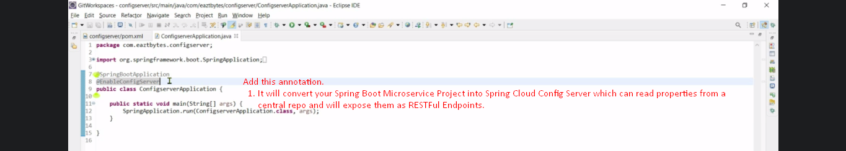
3. Step 03: Create properties files for different micro services and different environment.  
   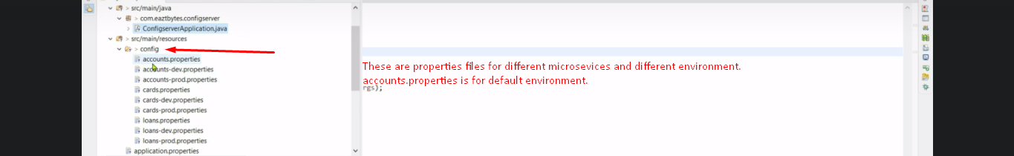
4. Step 04: Properties file location Configuration.  
     
   Native or Git Approach.